Module Assembly - TopCoder NodeJS Recent Winning Design Submissions API
Deployment Guide

Revision History
Author | Revision Number | Date
hesibo | 1.0 | 2014/03/17

Deployment Instructions 3
1. Organization of Submission 3
2. Application Setup 3
2.1. Preconditions 3
2.2. Build Script Setup 3
3. Database setup 4
4. Configurations 5
5. Deployment Instructions 5
6. Verification by tests 6
6.1. Js lint 6
6.2. Mocha 6
7. Verification by pages 7
8. Resource Contact List 13

Deployment Instructions

Organization of Submission
The folder structure (the root directory of the submission is referred as the <base> throughout the document.
Name | Description
tc-api/ | Main application source code of this assembly.  Contains only new or changed files.
tc-api/docs/Module Assembly - TopCoder NodeJS Recent Winning Design Submissions API.doc | This file.

Application Setup

Preconditions
- Linux 64bit System (preferably the Ubuntu 10.04), which is used by Heroku stack for Nodejs), with development tool, such as g++, maker.
- NodeJS 0.10.25 http://nodejs.org/
- Git
- Heroku Account and Toolbelt
  - Signup a Heroku account in https://api.heroku.com/signup/devcenter with your email address.
  - Download the Heroku Toolbelt from https://toolbelt.heroku.com, and make sure the Heroku CLI is working in your environment by typing the “heroku help”.
  - Login your Heroku account by typing the “heroku login”.
This requires you to input your email and password, and then finally it will upload your public SSH key to the server so that you don’t have to provide your credential during the subsequent commands.
If you have a “Permission denied (publickey)” error during deployment, you can use “heroku keys:add” to add the public key to the remote repo as described here.

Build Script Setup
Two BASH scripts are used to ease the deployment.
- deploy/development.sh
It helps to launch the application locally.
It simply exports the configured environment variables and then launch the Node.js application.
- deploy/heroku.sh
It helps to deploy the application onto the Heroku cloud.
It has command line switches.
Switch | Description
clean | It cleans the current repository information by simply removing the .git folder.
commit | It initializes the local repository and commits all the current project files, if the current directory is not a GIT repo yet; or commit all the changes to the local repository, if the current directory is already a GIT repo.
create | It creates a Heroku app for the current logged-in Heroku account.  This app will only be used if it is created when the current local GIT repo has not yet setup the remote repo of name “heroku”.  If your local repo has already setup “heroku” remote for an existing app, this app will not be picked as the target app for other Heroku commands. If you want to create an new Heroku app and use it as the target app in this case, you can clean and re-initialize the current local repo first, or you explicitly rebase it to the new Heroku app.
config | It exports all the configured environment variables to the target Heroku app.
push | It pushes the current committed version to the “heroku” remote.
launch | It launches one Heroku dyno to run the target app.
all | It will execute all other steps in the order: “clean”, “commit”, “create”, “config”, “push”, and then “launch”.
deploy | It only executes the steps to deploy the projects to the Heroku cloud: “config”, “push”, and then “launch”.  It assumes the code has been committed to the local repo, and the local repo has setup the “heroku” remote for the target app.

Database setup
TopCoder Informix Revision 84590 (https://coder.topcoder.com/internal/database/scripts/trunk/)

NOTE: Step 7 and 8 are not necessary if you first run mocha test on localhost (see section 6.2) and later test on heroku(see section 7).

- Upload the submission to /mnt/shared/temp_files/
- Login vm as ‘tc’ account
- cd /mnt/shared/temp_files
- unzip submission.zip
- su informix -l
- cd /mnt/shared/temp_files/submission/tc-api/db_scripts
- dbaccess - recent_winning_submissions_delete.sql
- dbaccess - recent_winning_submissions_create.sql

Configurations
There are two BASH scripts used to ease the deployments and launching of the application.
The configurations are defined in these scripts to export the environment variables.
One of them is for heroku development “tc-api/deploy/heroku.sh”, where the configurations are defined.
Please add heroku config:set TC_VM_IP=$TC_VM_IP
echo "INFO: Set environment variables"

heroku labs:enable user-env-compile

## Export the parameters
heroku config:set JAVA_HOME="/usr/lib/jvm/java-1.6.0-openjdk"
heroku config:set TC_VM_IP=$TC_VM_IP

No changes are required to tc-api/deploy/development.sh.

Deployment Instructions
- Setup heroku in section 2.1 and database in section 2.3.
- Run git clone git://github.com/cloudspokes/tc-api.git tc-api
- Run cd tc-api
- Run git checkout 219e890b80de6c5d0aba006dbcb7acfa1994f8d7
- Copy all files from <base>/tc-api to checked out tc-api and override all files
- Run npm install
- Modify configuration following section 4.
- In checked out tc-api run:
  - git add .
  - git commit –m “commit message”
  - chmod +x deploy/heroku.sh
  - export TC_VM_IP = <your-vm-address>
  - . deploy/heroku.sh all
  - After running the script, you can use “git remote -v” to see the “heroku” remote repo. The remote repo will be like git@heroku.com:<app-name>.git, you can know the create app name here.
- To deploy application in local environment run:
  - chmod +x deploy/development.sh
  - export TC_VM_IP = <your-vm-address>
  - . deploy/development.sh
  - node ./node_modules/.bin/actionHero start or npm start
  - Server is listening on port 8080.
  - If you get error Could not load default informix_bindings. Error: libthsql.so: cannot open shared object file: No such file or directory. Run again “. deploy/development.sh”

Verification by tests

Js lint
Install the node-jslint in your local environment globally by “sudo npm install jslint -g".
Check the following files (which contain the application code) under the <base>/tc-api
jslint -nomen actions/memberStatistics.js
jslint -nomen routes.js
jslint -nomen test/test.recentDesignWinningSubmissions.js

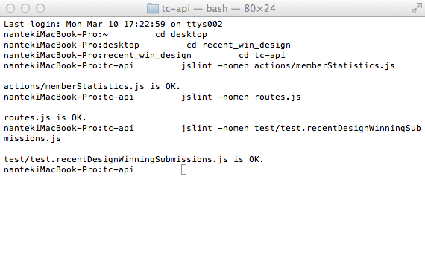

Mocha
Deploy application to localhost. See 5.8.
If you want to run test in another bash terminal, please run command 5.9.b and 5.9.c first.
Run the “node_modules/.bin/mocha test/test.recentDesignWinningSubmissions.js” from within the “<base>/tc-api/” directory
To run mocha test in heroku add this part “API_ENDPOINT=<app-name>.herokuapp.com”
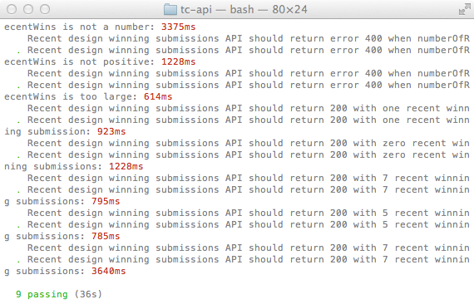

Verification by pages
To test application in heroku replace in below URLs localhost:8080 by <app-name>.herokuapp.com
You must generate data before testing. (refer section 3)

Verify application deployed in localhost

http://localhost:8080/api/v2/users/invalid/statistics/design/recentWins
No user found, expect 404.
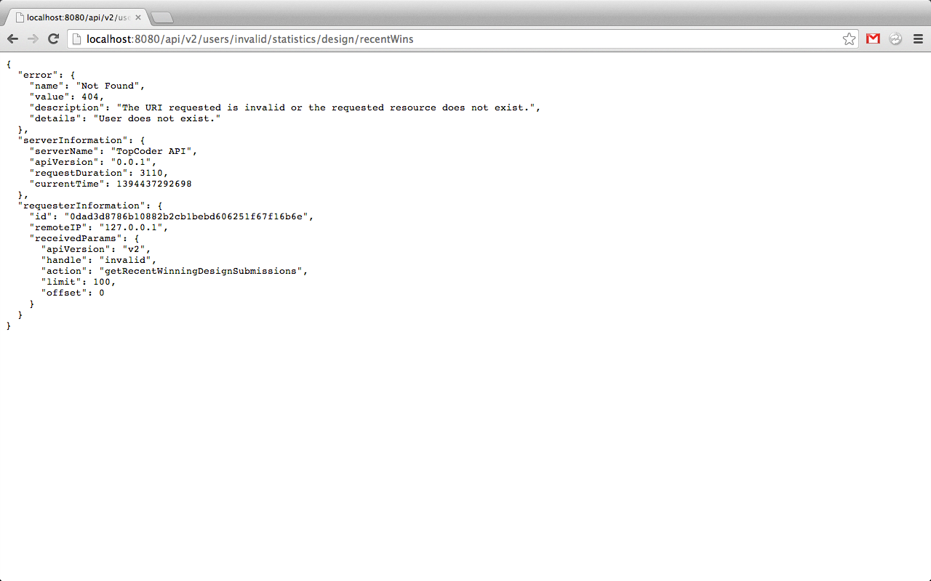

http://localhost:8080/api/v2/users/heffan/statistics/design/recentWins
No winning submissions for heffan.
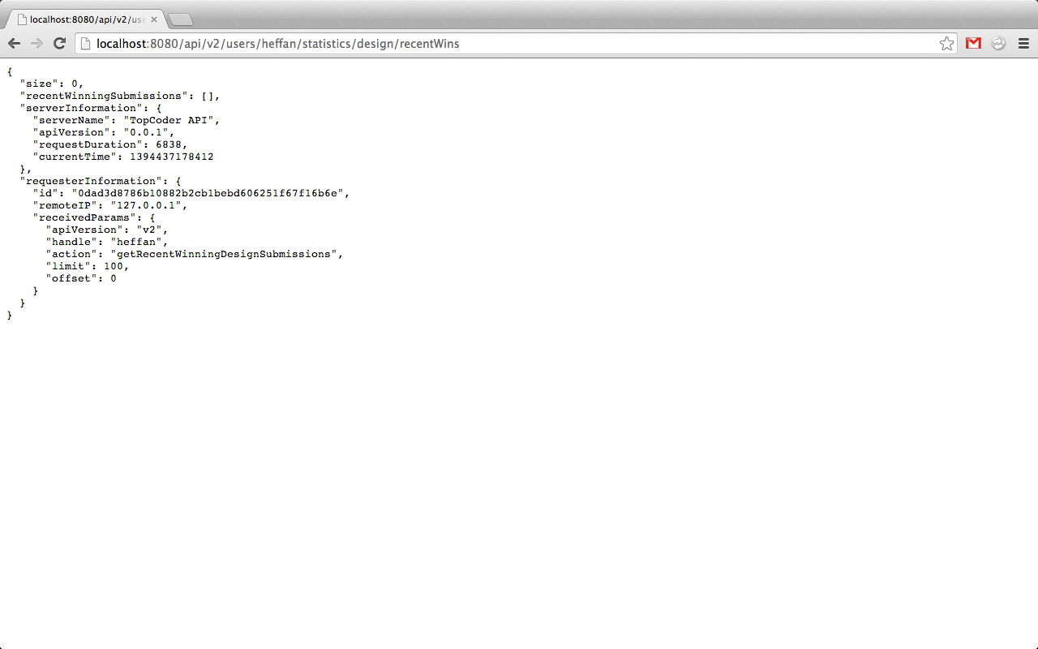

http://localhost:8080/api/v2/users/hung/statistics/design/recentWins?numberOfRecentWins=5
Only 2 submissions win for user ‘Hung’ so result only contain two items.
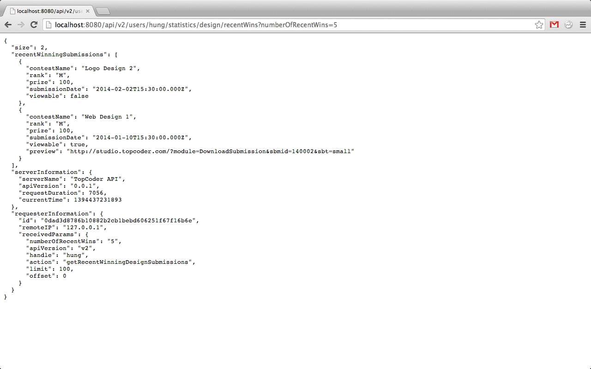

http://localhost:8080/api/v2/users/Partha/statistics/design/recentWins
The default parameter for numberOfRecentWins is 7, 7 items return.
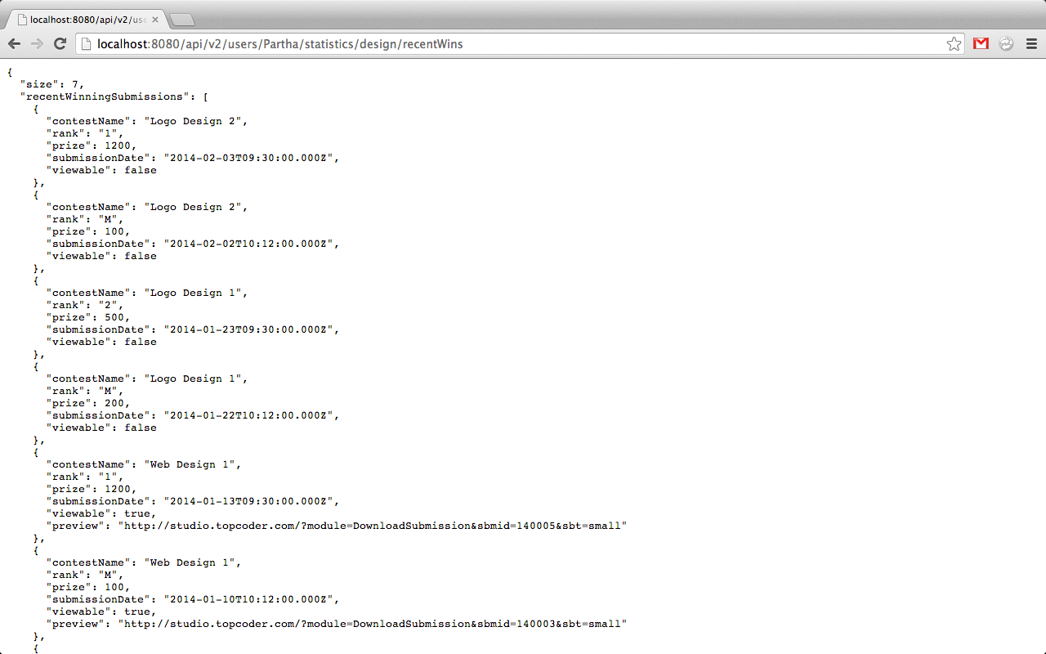

http://localhost:8080/api/v2/users/Partha/statistics/design/recentWins?numberOfRecentWins=5
Return first five recent design winning submissions for user ‘Partha’
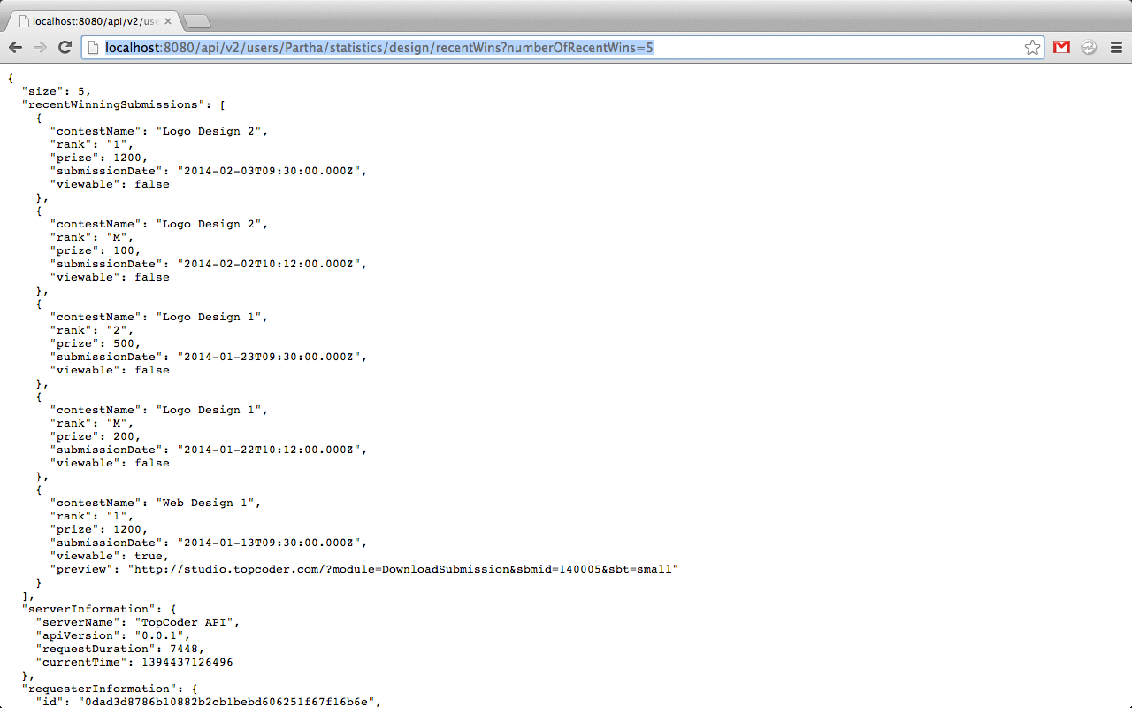

http://localhost:8080/api/v2/users/hung/statistics/design/recentWins?numberOfRecentWins=0
numberOfRecentWins is not positive, expect 400
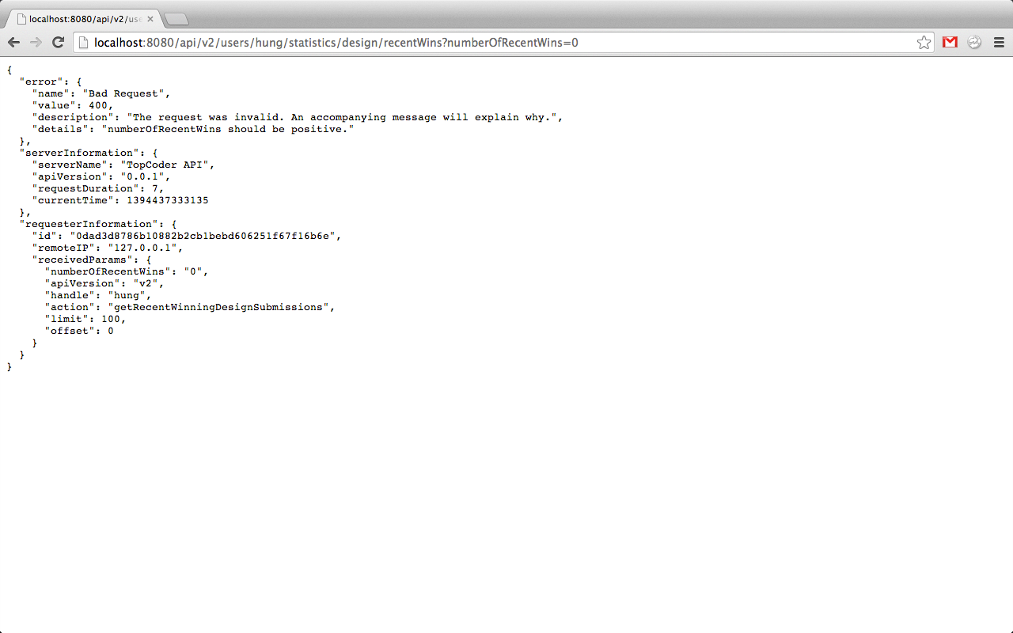

Verify application deployed in Heroku

http://<app-name>.herokuapp.com/api/v2/users/hung/statistics/design/recentWins?numberOfRecentWin=999999999999
numberOfRecentWins is too large, expect 400
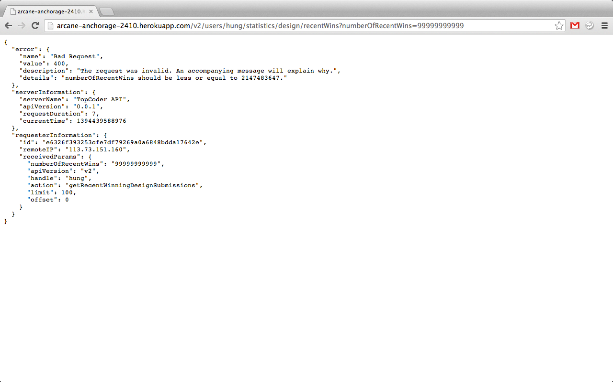

http://<app-name>.herokuapp.com/api/v2/users/hung/statistics/design/recentWins?numberOfRecentWin=5
User ‘Hung’ only have two design winning submissions, return two items.

http://<app-name>.herokuapp.com/api/v2/pArtha/hung/statistics/design/recentWins
Default numberOfRecentWins is 7, so 7 items return for user ‘Partha’
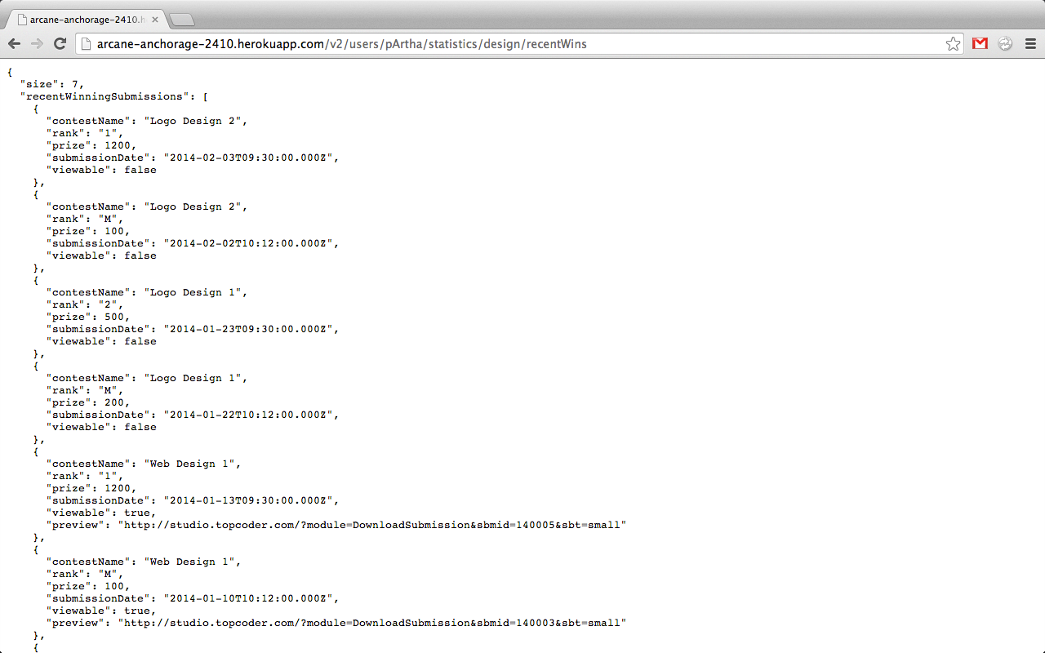

Resource Contact List
Name | Resource Email

